EXPERIMENT 2

AIM :
Characteristics Study of Side Band Power and Frequencies in AM using MATLAB

SOFTWARE REQUIRED:
MATLAB Simulink

PROGRAM:

clc; clear; close all;

Ac=5; Am=2;
fc=1000; fm=100;
m=Am/Ac;

t=0:1e-5:0.05;
x=Ac*(1+m*cos(2*pi*fm*t)).*cos(2*pi*fc*t);

USB=fc+fm;
LSB=fc-fm;
Pc=Ac^2/2;
Psb=m^2*Pc/4;

disp(['LSB = ',num2str(LSB),' Hz']);
disp(['USB = ',num2str(USB),' Hz']);
disp(['Carrier Power = ',num2str(Pc),' W']);
disp(['Sideband Power = ',num2str(Psb),' W']);

plot(t,x);
xlabel('Time'); ylabel('Amplitude');
title('AM Signal');
grid on;

OUTPUT:

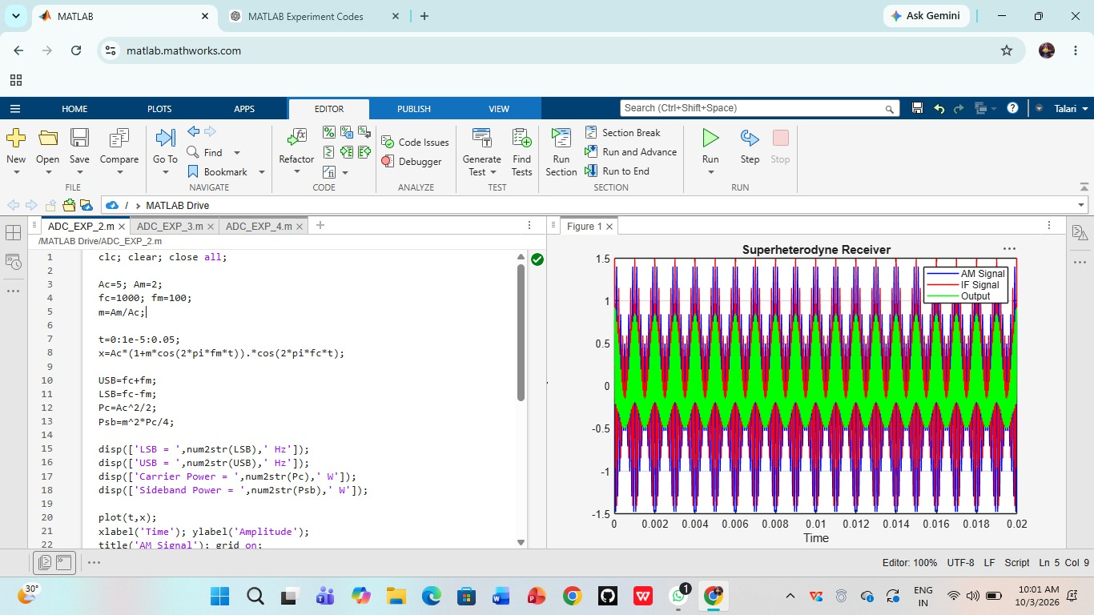

RESULT:

Thus, the characteristics of sideband frequencies and powers in AM were successfully studied using MATLAB.

